Assignment-1

SQL Database Objects Reference Sheet

This reference sheet lists common database objects in SQL along with brief descriptions. These objects define the structure, logic, and security of the database.

|  |  |
| --- | --- |
| Database Object | Description |
| Table | Stores data in rows and columns; the primary storage unit in SQL. |
| View | A virtual table based on the result-set of an SQL query. |
| Index | Improves the speed of data retrieval from a table. |
| Stored Procedure | A saved collection of SQL statements that perform a task. |
| Function | Returns a value and can be used in SQL expressions; similar to procedures. |
| Trigger | Executes automatically in response to certain events on a table or view. |
| Schema | A logical container for database objects; helps organize them. |
| Sequence | Generates a sequence of numeric values, often used for auto-incrementing IDs. |
| Synonym | An alias for another database object to simplify access. |
| Constraint | Rules applied to table columns for data validation and integrity. |

**2**.**what are the metadata tables we have in sql**?

| **Metadata Table** | **Description** |
| --- | --- |
| INFORMATION_SCHEMA.TABLES | Lists all tables in the database |
| INFORMATION_SCHEMA.COLUMNS | Lists all columns in all tables |
| INFORMATION_SCHEMA.SCHEMATA | Lists all schemas |
| INFORMATION_SCHEMA.CONSTRAINTS | Lists table constraints (PK, FK, UNIQUE, etc.) |
| INFORMATION_SCHEMA.KEY_COLUMN_USAGE | Links constraints to their columns |
| INFORMATION_SCHEMA.VIEWS | Lists all views in the database |
| INFORMATION_SCHEMA.ROUTINES | Lists stored procedures and functions |
| INFORMATION_SCHEMA.TRIGGERS | Lists triggers |

**Vendor-Specific Metadata Tables**

Depending on your database system, there are more detailed system views or tables:

**SQL Server**

| **System View / Table** | **Purpose** |
| --- | --- |
| sys.tables, sys.columns | Lists tables and columns |
| sys.objects, sys.schemas | All database objects and schemas |
| sys.indexes, sys.index_columns | Index metadata |
| sys.procedures, sys.triggers | Stored procedures and triggers |
| sys.foreign_keys, sys.check_constraints | Constraints |

**MySQL**

| **System Table** | **Purpose** |
| --- | --- |
| information_schema.TABLES | Table metadata |
| information_schema.STATISTICS | Index metadata |
| mysql.user, mysql.db | User privileges and database access |

**PostgreSQL**

| **System View / Table** | **Purpose** |
| --- | --- |
| pg_tables, pg_class | Table information |
| pg_attribute | Column info |
| pg_indexes, pg_index | Index info |
| pg_constraint | Constraints |
| pg_proc | Functions and procedures |

**Oracle**

| **System View** | **Purpose** |
| --- | --- |
| ALL_TABLES, ALL_TAB_COLUMNS | Tables and columns |
| USER_CONSTRAINTS, USER_INDEXES | Constraints and indexes |
| DBA_OBJECTS, DBA_TABLES | All objects in the database |

**SQL Server (T-SQL)**

**1. List All Tables**

sql

CopyEdit

SELECT name, schema_id

FROM sys.tables;

**2. List All Columns in a Specific Table**

sql

CopyEdit

SELECT name, column_id, system_type_id

FROM sys.columns

WHERE object_id = OBJECT_ID('YourTableName');

**3. List Indexes on a Table**

sql

CopyEdit

SELECT i.name AS IndexName, i.type_desc, c.name AS ColumnName

FROM sys.indexes i

JOIN sys.index_columns ic ON i.object_id = ic.object_id AND i.index_id = ic.index_id

JOIN sys.columns c ON ic.object_id = c.object_id AND ic.column_id = c.column_id

WHERE i.object_id = OBJECT_ID('YourTableName');

**4. List All Stored Procedures**

sql

CopyEdit

SELECT name, type_desc

FROM sys.procedures;

**✅ MySQL**

**1. List All Tables**

sql

CopyEdit

SELECT table_name

FROM information_schema.tables

WHERE table_schema = 'your_database';

**2. List All Columns in a Table**

sql

CopyEdit

SELECT column_name, data_type, is_nullable

FROM information_schema.columns

WHERE table_name = 'your_table' AND table_schema = 'your_database';

**3. List Indexes on a Table**

sql

CopyEdit

SHOW INDEXES FROM your_table;

**4. List Stored Procedures**

sql

CopyEdit

SELECT routine_name, routine_type

FROM information_schema.routines

WHERE routine_schema = 'your_database';

**✅ PostgreSQL**

**1. List All Tables**

sql

CopyEdit

SELECT tablename

FROM pg_tables

WHERE schemaname NOT IN ('pg_catalog', 'information_schema');

**2. List Columns in a Table**

sql

CopyEdit

SELECT column_name, data_type

FROM information_schema.columns

WHERE table_name = 'your_table';

**3. List Indexes**

sql

CopyEdit

SELECT indexname, indexdef

FROM pg_indexes

WHERE tablename = 'your_table';

**4. List All Functions**

sql

CopyEdit

SELECT proname, proargtypes

FROM pg_proc

JOIN pg_namespace ON pg_proc.pronamespace = pg_namespace.oid

WHERE nspname NOT IN ('pg_catalog', 'information_schema');

**✅ Oracle**

**1. List All Tables**

sql

CopyEdit

SELECT table_name FROM user_tables;

**2. List Columns in a Table**

sql

CopyEdit

SELECT column_name, data_type

FROM user_tab_columns

WHERE table_name = 'YOUR_TABLE';

**3. List Constraints**

sql

CopyEdit

SELECT constraint_name, constraint_type, table_name

FROM user_constraints;

**4. List Indexes**

sql

CopyEdit

SELECT index_name, table_name

FROM user_indexes;

**Assignment-2**

**1.create table and change table name ,update,commit,delete,rollback concepts?**

**After created and alter inserted in table:**

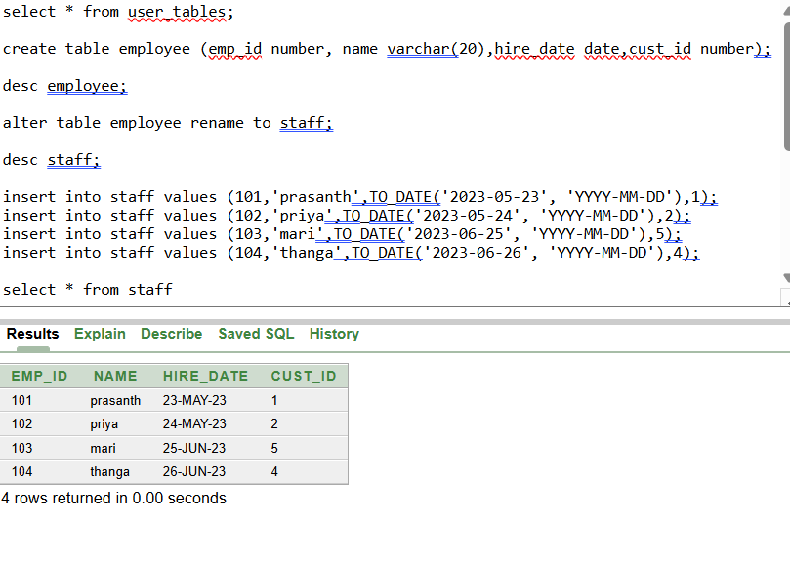

INSERTED VALUES IN TABLE

**Updated cust_id=3 value in staff table:**

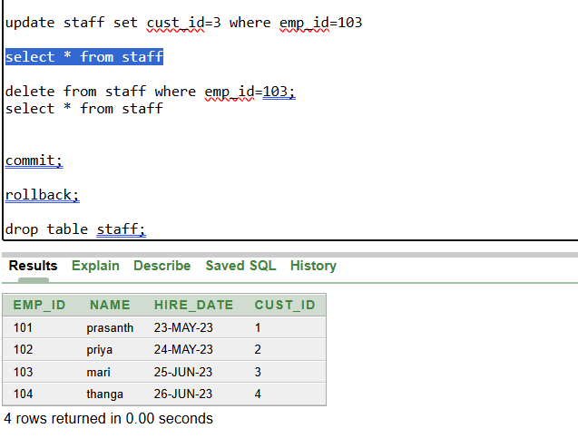

UPDATED VALUES

**Commit the table after updating:**

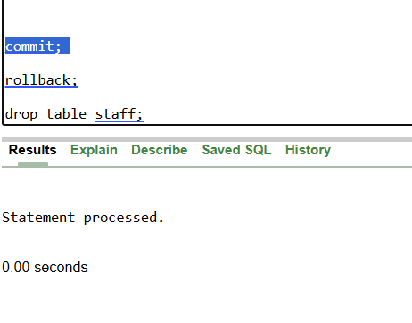

**Delete the emp_id =103 in table:**

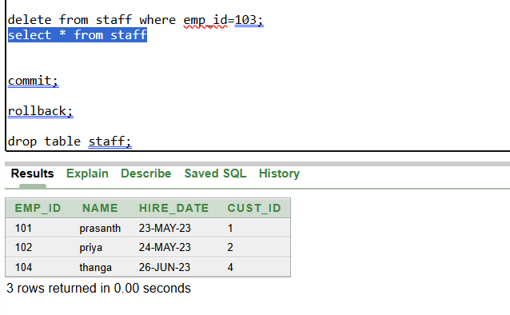

DELETED 103 ROW

**Rollback is to retrieve deleted data from table but before there shouldn’t be commited otherwise rollback wont comes in play…**

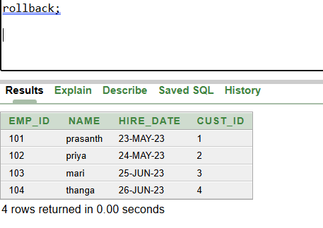

RESTORED EMP_ID=103;

**2.create table and checking how its works:**

**create table student(id number,name varchar(20),subject varchar(20),marks number); (table created comes under DDL so AUTOCOMMIT )**

**insert into student(id, name,subject,marks) values (1001,'jyo','maths',80)(table insert comes under DML so no autocommit)**

**insert into student(id, name,subject,marks) values (1002,'pras','maths',85) (table insert comes under DML so no autocommit)**

**insert into student(id, name,subject,marks) values (1003,'master','maths',90) (table insert comes under DML so no autocommit)**

**select * from student;**

**create table student1(id number,name varchar(20),subject varchar(20),marks number); (table created comes under DDL so AUTOCOMMIT )**

**insert into student1(id, name,subject,marks) values (1001,'jyo','maths',80) (table insert comes under DML so no autocommit)**

**insert into student1(id, name,subject,marks) values (1002,'pras','maths',85) (table insert comes under DML so no autocommit)**

**truncate table student1;(TRUNCATED ONLY MENTIONED TABLE STUDENT1)**

**select * from student1;**

**rollback;(HERE TABLE1 INSERTION IS NOT COMMIT SO IT WILL ROLLBACK TO EMPTY FOR STUDENT TABLE AND ANOTHER TABLE ALREADY TRUNCATED….)**

**create table student2(id number,name varchar(20),subject varchar(20),marks number); (table created comes under DDL so AUTOCOMMIT )**

**insert into student2(id, name,subject,marks) values (1001,'jyo','maths',80) (table insert comes under DML so no autocommit)**

**insert into student2(id, name,subject,marks) values (1002,'pras','maths',85) (table insert comes under DML so no autocommit)**

**commit; (HERE STUDENT2 TABLE IS COMMIT)**

**select * from student2;**

**SO, FINALLY**

**STUDENT TABLE ROLLBACK**

**STUDENT1 TABLE TRUNCATED**

**STUDENT2 TABLE COMMIT**

**Assignment-3**

**1.check wheather we can use multiple constraints in single column?**

**Yes, you can apply multiple constraints to a single column**

**Ex;**

**CREATE TABLE employees (**

**emp_id INT PRIMARY KEY,**

**email VARCHAR(100) NOT NULL UNIQUE,**

**salary DECIMAL(10, 2) NOT NULL CHECK (salary > 0)**

**);**

**Here Common column-level constraints you can combine:**

**Not null**

**Unique**

**Default**

**Check**

**But here,primary key should be in for one field only and that should associate with reference foreign key if needed**

**So, we cant use multiple primary key in single column,, remaining keys we can use multiple times**

**Composite Primary Key: we have this key to use one or more column to identify unique values….**

**PRIMARY KEY (student_id, course_id)**

**Here, student_id cant able to find unique value so we associate with another course_id to filter perfect unique value**

**2.create two table using constraints associated?**

**Create order table and insert value:**

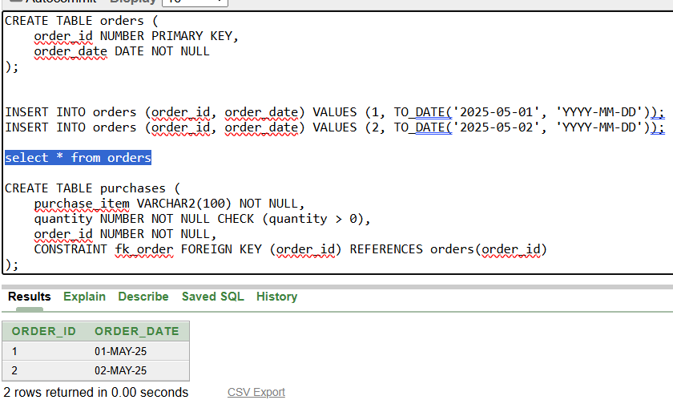

**Create purchase table and insert values:**

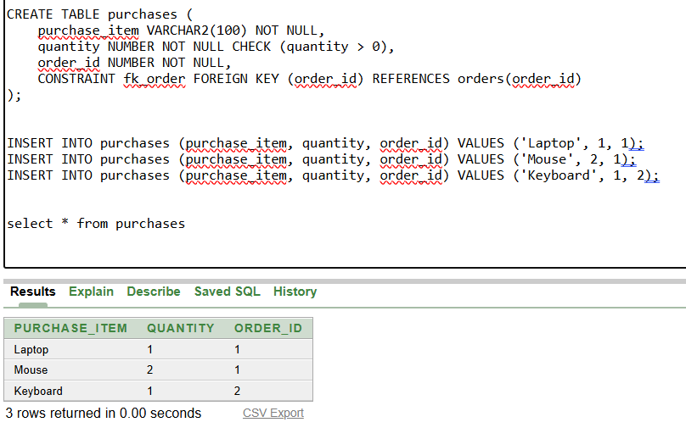

**Check whether primary and foreign key associated correctly**

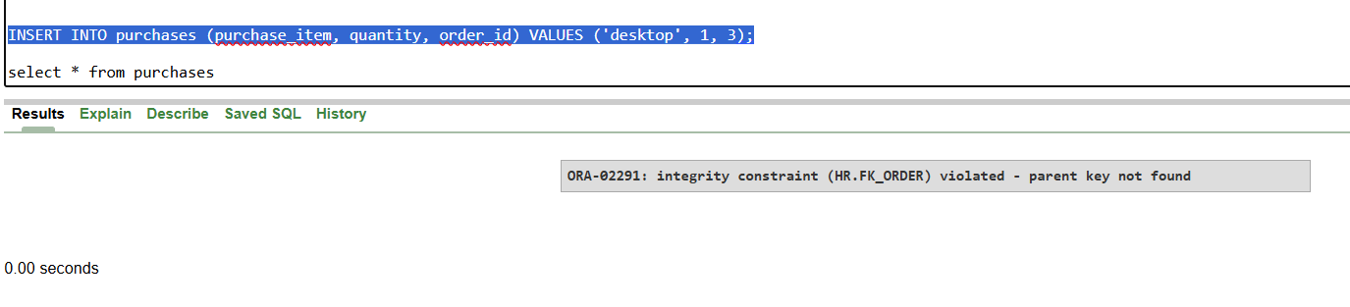

**Here, I change purchase order_id to 3 which is not in primary key orders table errors:parent key not found**

**So,here confirmed foreign key is reference to primary key order table and if we want to use that means their should be common id with unique value association is must**

**Assignment-4**

**1.create user access from hr to user, user to user1 and access hr tables from user1?**

**Create hr to user(prasanth):**

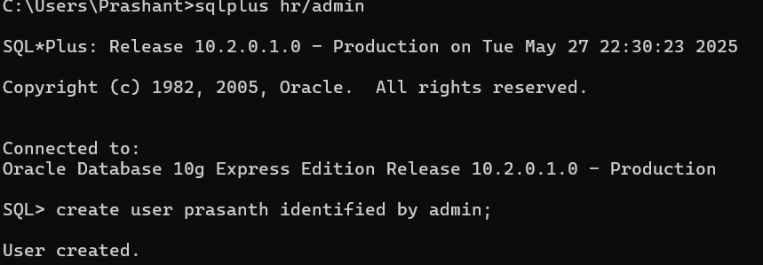

**Grand access:**

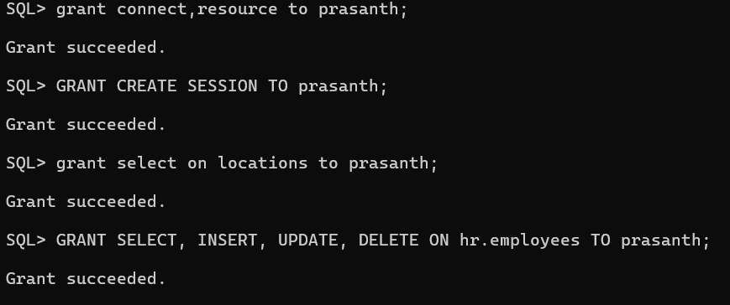

**create user1(mari) from user(prasanth)**

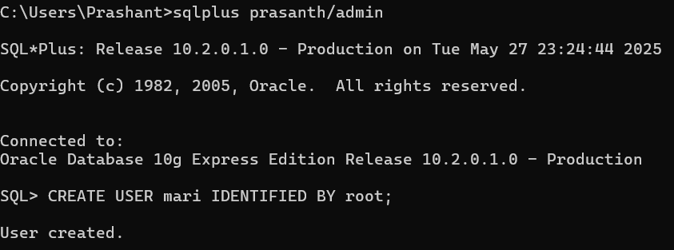

**But to start session for user1(mari) I used PRIVILEGE option to user(prasanth):**

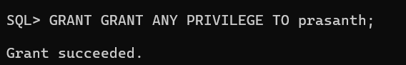

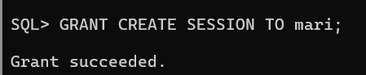

**Now from user(prasanth) to user1(mari) successfully connected:**

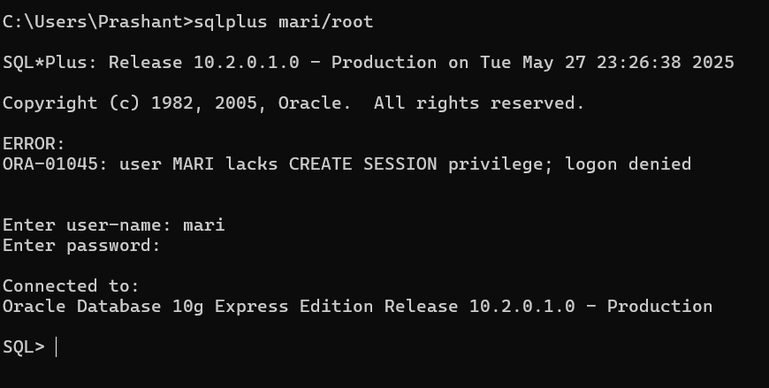

**Now task is to access hr table to user1(mari):**

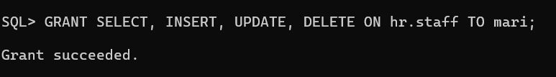

**Here I deleted and rollback data of hr.staff table in user1(mari):**

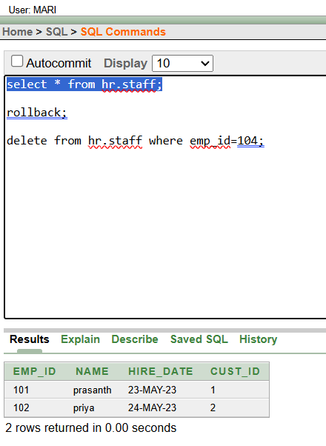

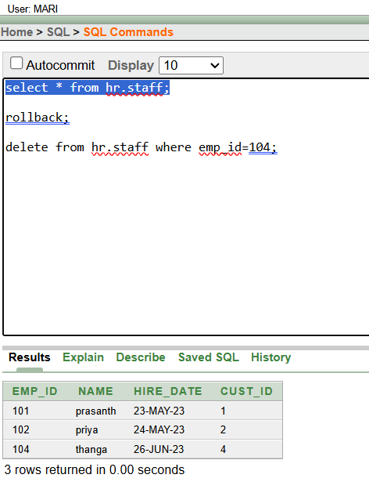

**So,successfully accessed hr table using user1(mari)**

**2.how to drop or delete user in database?**

**Here 3 users I have :**

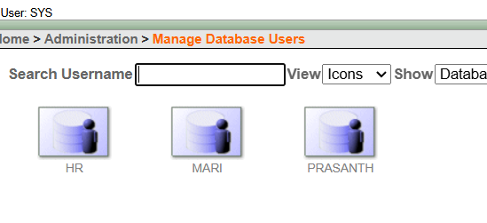

**After disconnecting user(prasanth):**

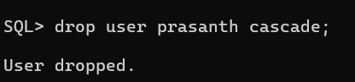

**After droping user(prasanth) in manage users we have only:**

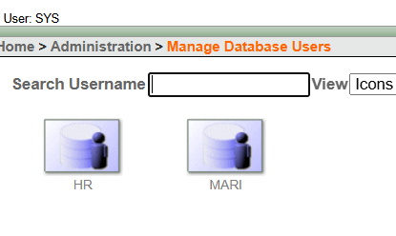

**So,successfully droped user(prasanth)…**

**Assignment-5**

**1.load 3 datas in table and again load 3 datas in same table?**

**Loading csv(comma separate value file) using ctl(control file) thru command line:**

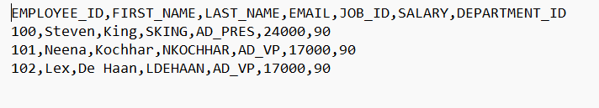

**CSV FILE**

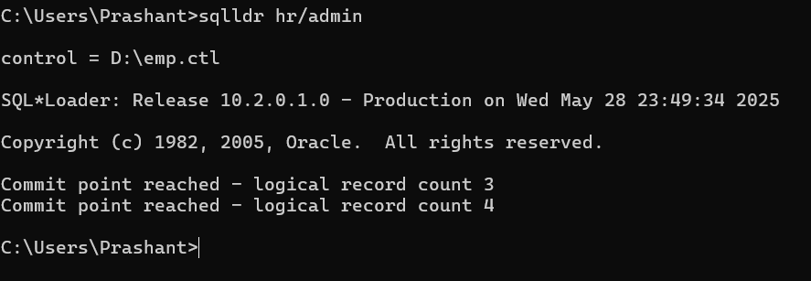

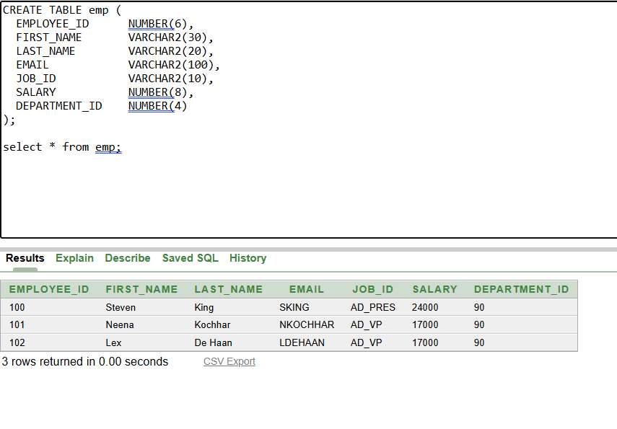

**Again adding using append command:**

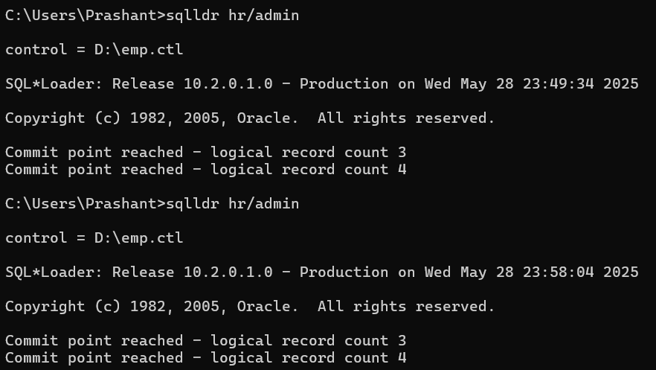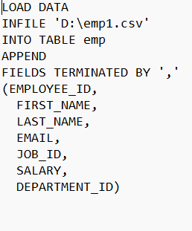

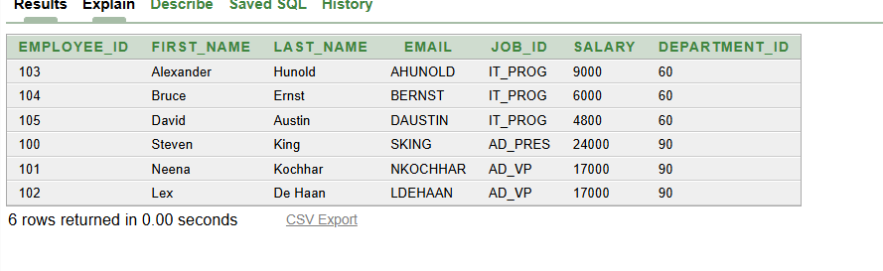

**Assignment-6**

**1.do joins for 3 tables only matching tables to view:**

**Here employees,departments and job_history has common department_id to join:**

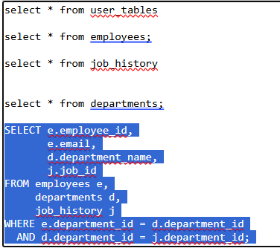

**OUTPUT:**

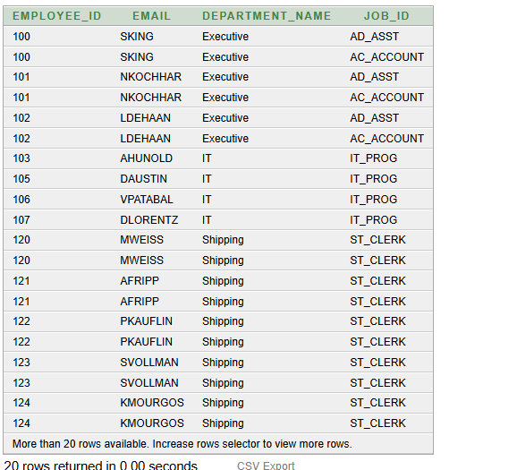

**Assignment-7**

1. **find metadata for sequence to know what are the sequence available in current user?**

**View all sequences accessible to the current user: SELECT * FROM ALL_SEQUENCES;**

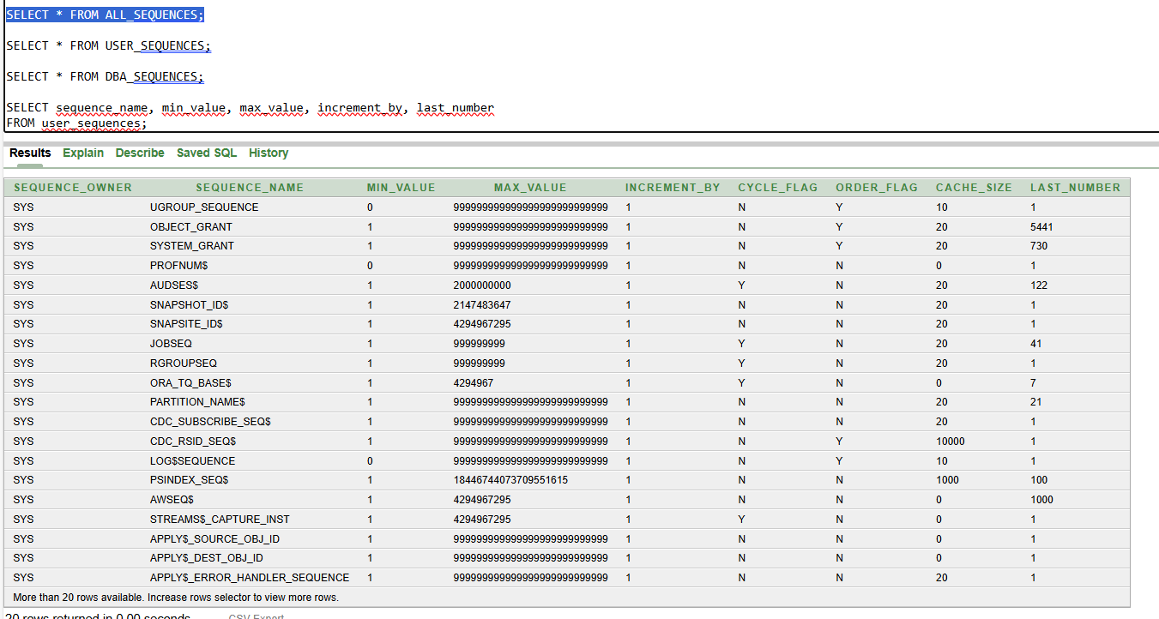

**This view includes all sequences that the current user has access to, including those owned by other users**

**View only the sequences owned by the current user:** **SELECT * FROM USER_SEQUENCES;**

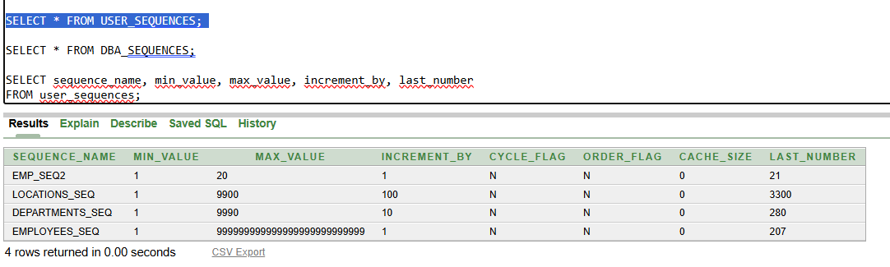

**This view is filtered to only show sequences owned by the current user.**

**View all sequences in the database same as all sequences:** **SELECT * FROM DBA_SEQUENCES;**

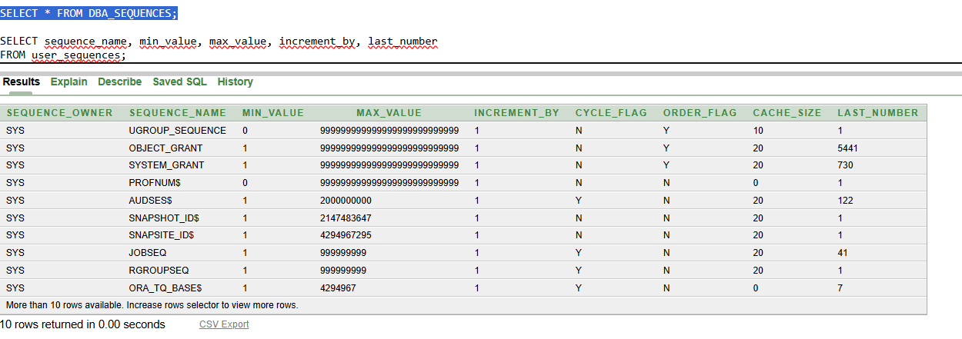

**SEQUENCE_NAME: Name of the sequence.**

**MIN_VALUE: Minimum value of the sequence.**

**MAX_VALUE: Maximum value.**

**INCREMENT_BY: The increment step.**

**CYCLE_FLAG (Y/N):**

* **'Y' means the sequence restarts from the MINVALUE after reaching MAXVALUE.**
* **'N' means it will throw an error once it exceeds MAXVALUE.**

**ORDER_FLAG (Y/N):**

* **'Y' guarantees that sequence numbers are generated in order, important in RAC (Real Application Clusters) environments.**
* **'N' does not guarantee strict ordering (but is faster).**

**CACHE_SIZE:**

* **Number of sequence numbers kept in memory for faster access. Higher cache reduces disk access but risks value loss in crash.**

**LAST_NUMBER:**

* **Indicates the next number to be generated after the cached values are exhausted. It may not reflect the most recently generated number if caching is in use.**

1. **create a table and insert value by using sequence?**

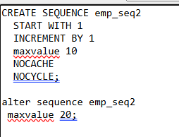

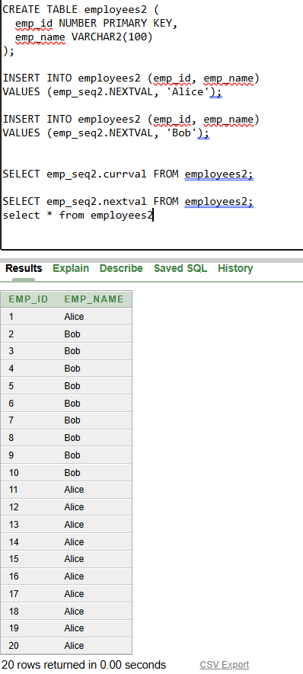

**Assignment-8**

**GROUP BY**

1. **HOW MANY EMPLOYEE WORKING DEPARTMENT WISE?**

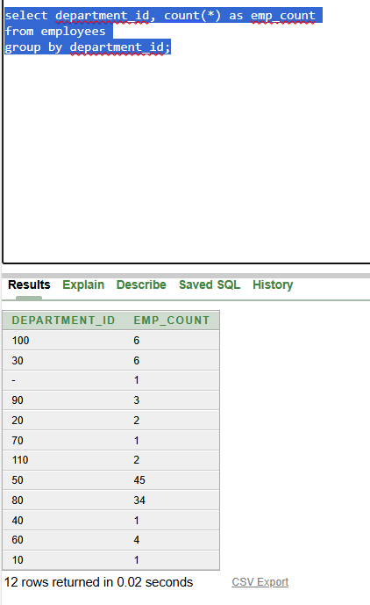

**based on country_id in location table:**

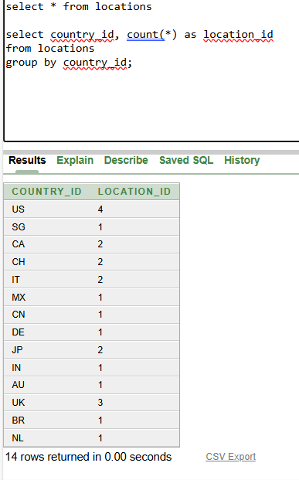

**Assignment-9**

**To find what are the views available in schema, what are the metadata table we using:**

**To find all views available in a schema in Oracle Database,**

**you can query the data dictionary views (metadata**

**tables). Here are the main ones used:**

**1. USER_VIEWS:**

**Lists all views owned by the current user.**

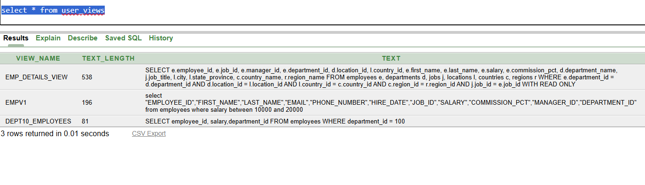

**2. ALL_VIEWS:**

**Lists all views accessible to the current user (including views owned by others if you have privileges).**

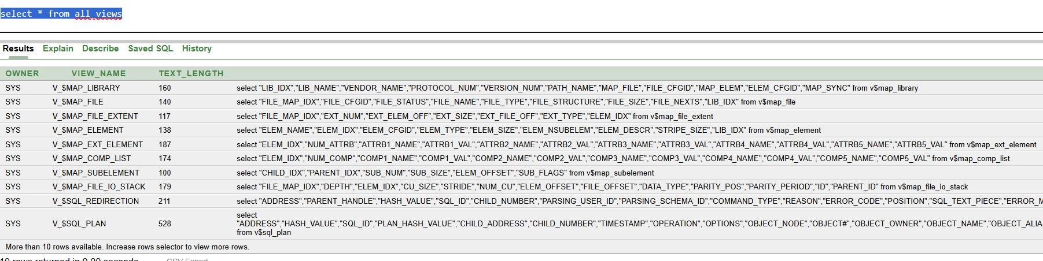

**3. DBA_VIEWS:**

**Lists all views in the entire database, across all**

**schemas. *(requires DBA privileges)***

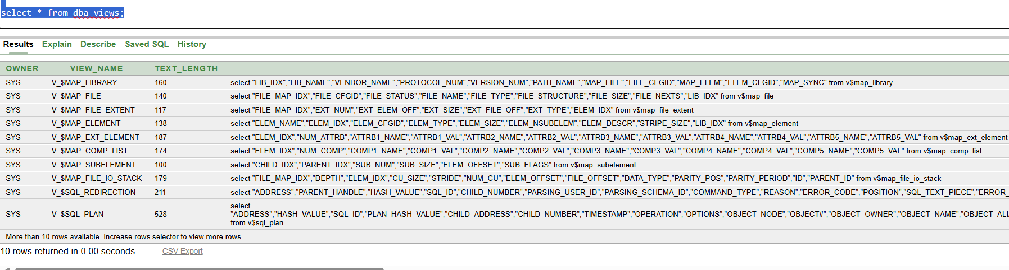

| **Column Name** | **Description** |
| --- | --- |
| **VIEW_NAME** | **Name of the view** |
| **TEXT** | **SQL query text that defines the view** |
| **OWNER** | **Owner of the view (only in ALL_ / DBA_)** |

**Example: Show All Views and Their SQL Definition:**

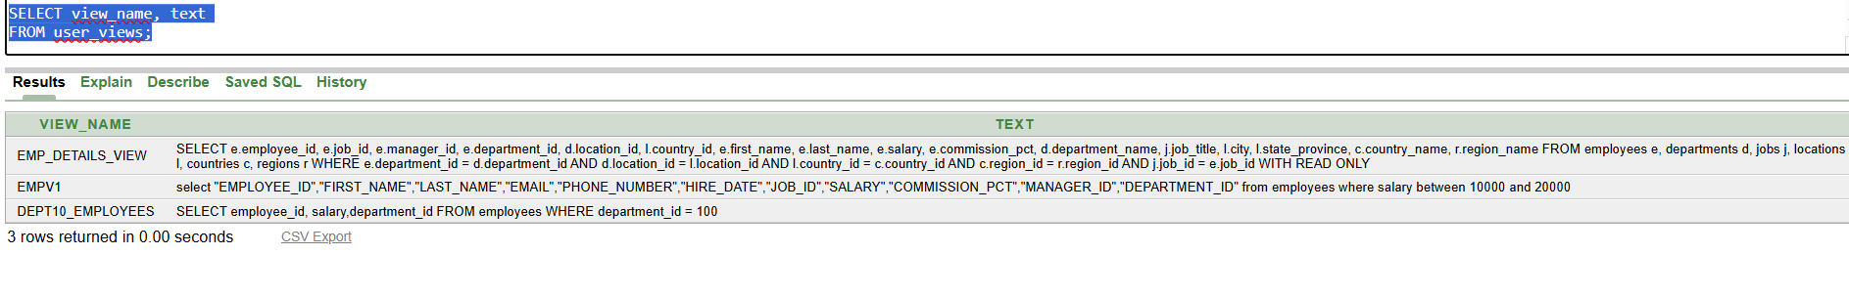

**To see the SQL query behind a view in a formatted way, use:**

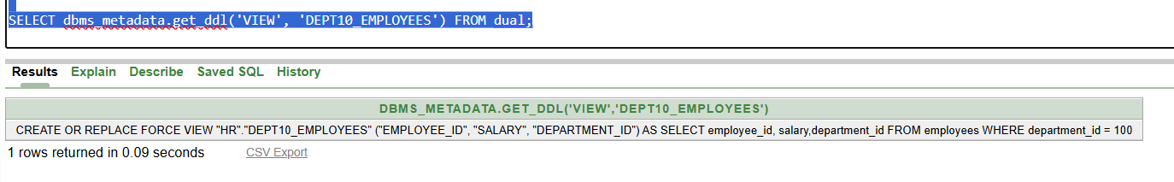

**4. Get the Columns of a View**

**Use the USER_TAB_COLUMNS, ALL_TAB_COLUMNS, or**

**DBA_TAB_COLUMNS metadata views:**

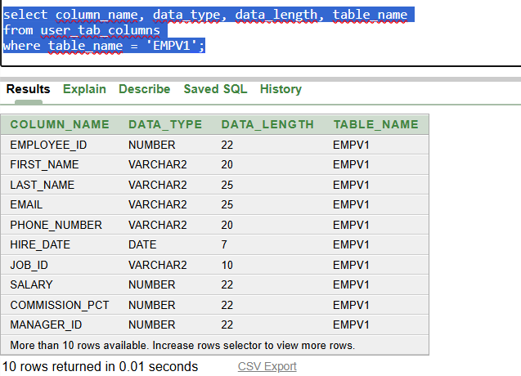

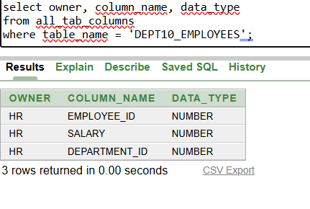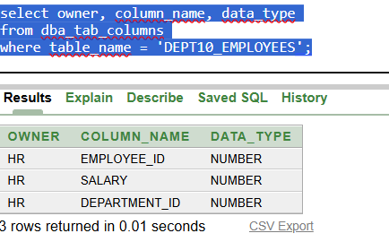

**View names are stored in uppercase by default in Oracle.**

**5.** **Find Views That Use a Specific Table:**

**Example: Find views that use the EMPLOYEES table:**

**DBMS_METADATA.GET_DDL works for all version to search specific table VIEWS**

**Here I used for EMPLOYEE_ID and EMAIL:**

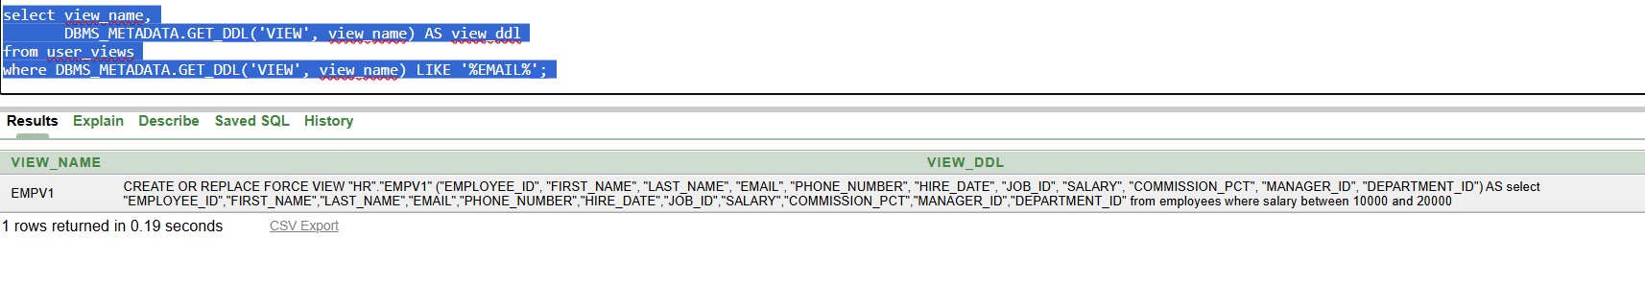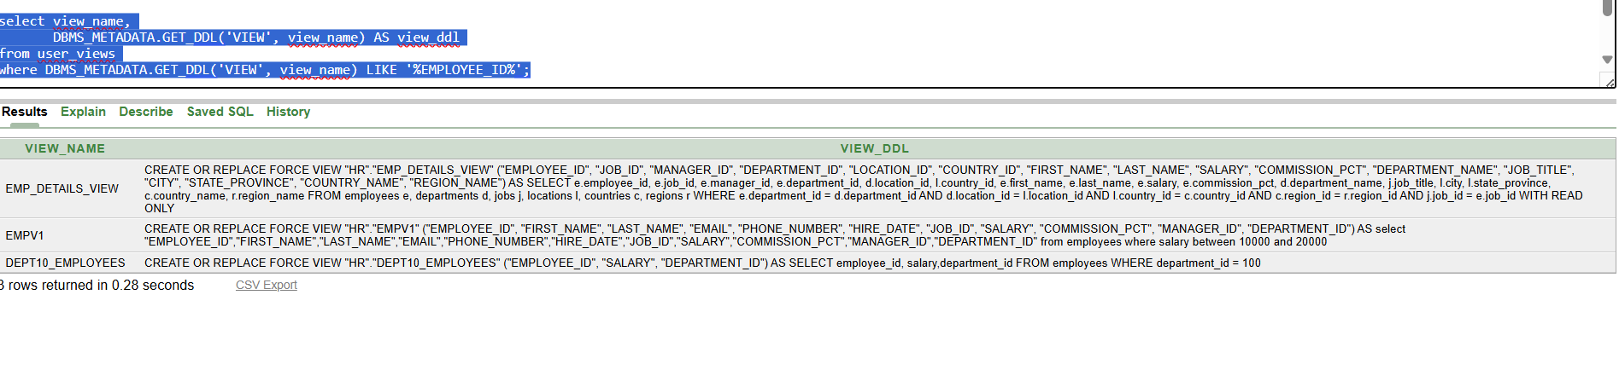

**Summary of Metadata Tables Used for Views**

| **Purpose** | **Metadata View** |
| --- | --- |
| **List views in current schema** | **USER_VIEWS** |
| **List all views accessible to user** | **ALL_VIEWS** |
| **List all views in the database** | **DBA_VIEWS** |
| **Find view definitions (SQL)** | **TEXT column or DBMS_METADATA.GET_DDL** |
| **List columns in a view** | **USER_TAB_COLUMNS** |
| **List view columns across all users** | **ALL_TAB_COLUMNS / DBA_TAB_COLUMNS** |

**Assignment-10**

**How to add external tables using csv and txt file:**

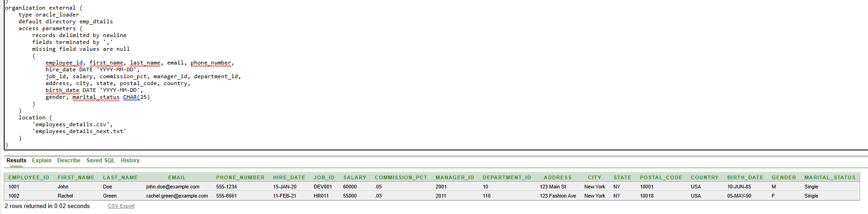

**Selecting all directories:**

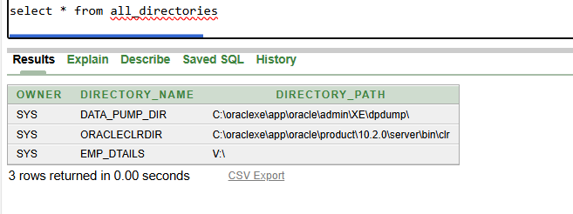

**When working on external tables the most commonly used format is CSV**

**Droping directories is possible only,when we have DROP ANY DIRECTORY privilege access:**

**drop directory directory_name;**

**still,** **this command only removes the reference in Oracle, not the actual folder on the filesystem.**

**If you want to move data from external to permanent table:**

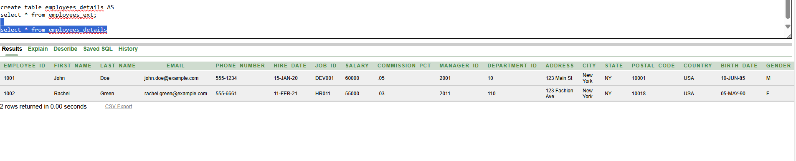

**Now employees_details is a normal Oracle table.**

**To check current users privileges:**

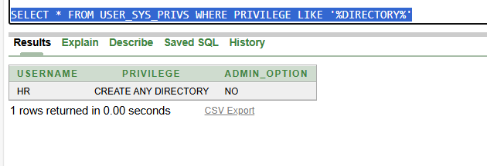

**Assignment-11**

**1.find the 2nd highest salary using subquery and display all details?**

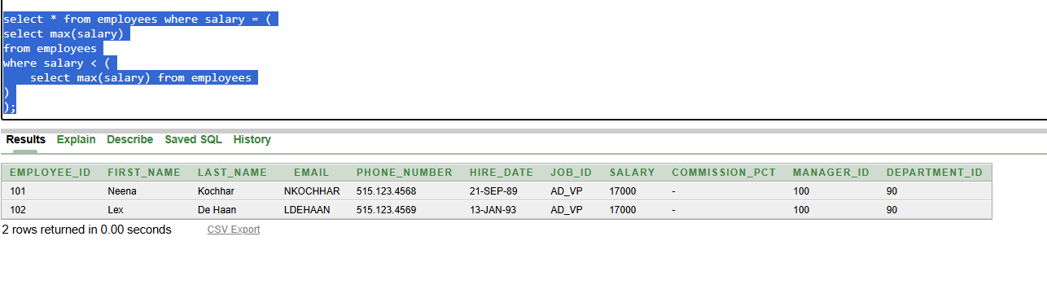

**2.** **who are all get highest salary from department wise using multi column subquery?**

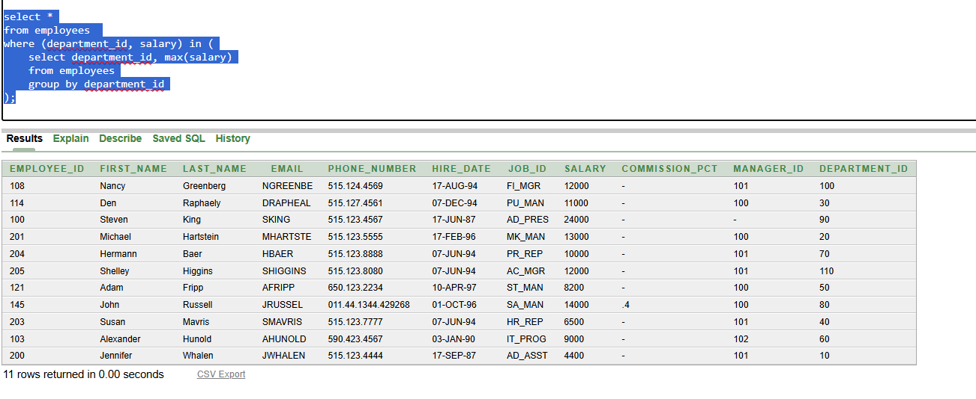

**3.** **current salary of employees, max_salary and min_salary of employees and display first_name,salary,max_salary,min_salary?**

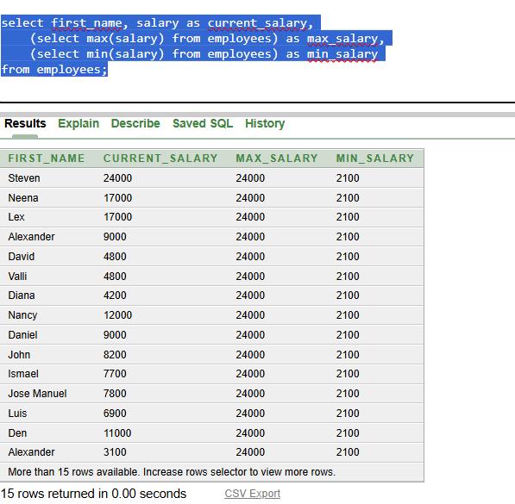

**Assignment-12**

**1.need to print *** in before and after string using lpad &rpad**

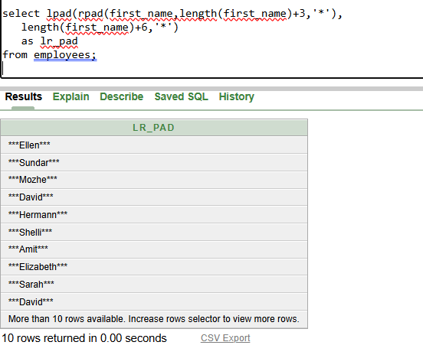

**lpad,rpad(string, total_length,pad_string)**

**Explaination: for ellen**

**Inner fn execute first rpad(ellen,5+3=8,’*’) ans = ellen\*\*\***

**Then in lpad(ellen*** as a string, 5+6=11,’*’)=***ellen\*\*\***

**here updated rpad string length became 8 so we adding +6 in actual string to tally rpad additional +3**

**output:**

**\*\*\*ellen\*\*\***

**2.** **create table in the name of emp add a column in name of**

**NAME insert 3values print words in between 2 and 3 (A)?**

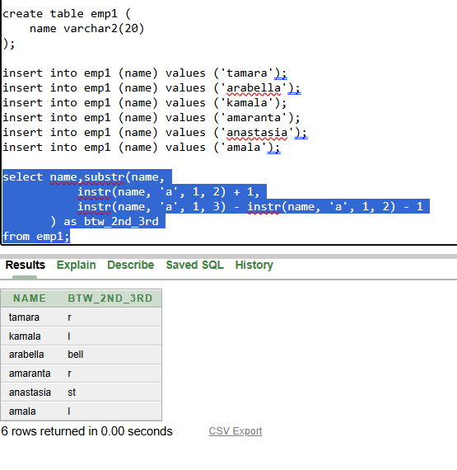

**Explaination:**

**For tamara first we execute inside substr to find first position and length of the string so,**

**Syntax of substr:**

**Substr(string, first_position, length)s**

**Finding First_position:**

**we use instr,syntax**

**Instr(string, substring, start_pos, occurance):**

**Instr(tamara, ‘a’, 1 , 2) 🡺pos = 4 but we need next value of a so +1**

**First_position = Instr(tamara, ‘a’, 1 , 2) +1 = 4+1 = 5**

**Length:**

**Logic: (3rd pos - 2ndpos - 1) 🡺to find length of the string in between**

**instr(tamara, ‘a’, 1, 3) - instr(tamara, ‘a’, 1, 2) - 1 = 1**

**6 - 4 - 1 = 1**

**So finally we got substr(tamara, 5,1)**

**Output:**

**r**

**assignment-13**

1. **Try to print others by using case statement:**

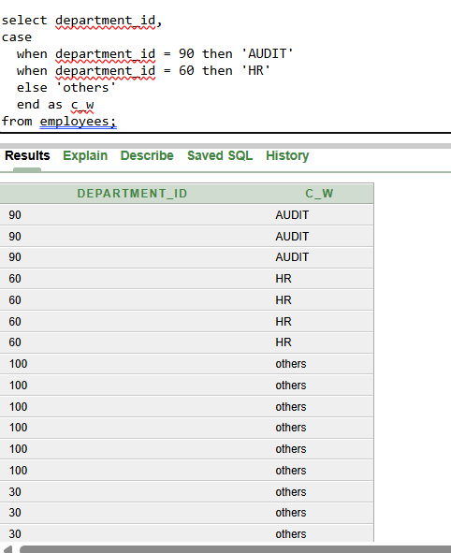

1. **print the first_date of the month**

